Software-Defined Networking

Lab 5

Midterm Lab

University of Colorado Boulder

Department of Computer Science

Professor Levi Perigo, Ph.D.

# Summary

The objective of this lab is to recall and apply all the knowledge you have gained so far in this course. You will utilize the knowledge of traditional networking, software-defined networking, virtual switches, controllers, OpenFlow, packet capturing, GNS3 and Python. Students are encouraged to expand on the topics for additional learning and experiments.

# Objective 1 – Set up topology in GNS3

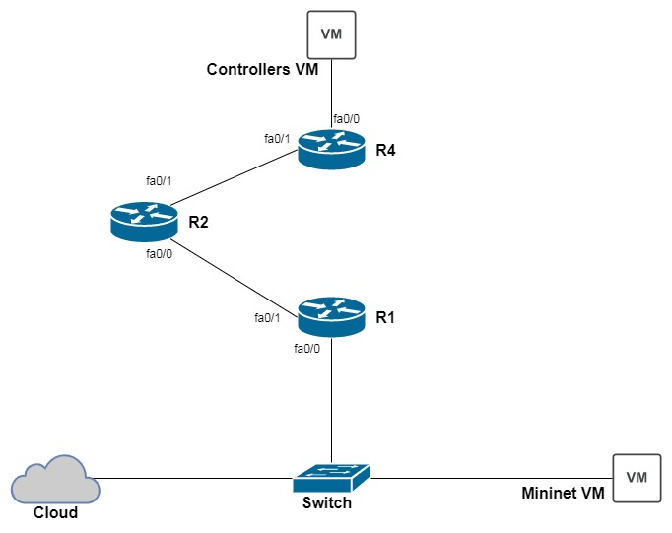

|  |  |  |
| --- | --- | --- |
| **Device** | **Interface** | **IP address** |
| **R1** | fa0/0 | 192.168.100.1/24 |
|  | fa1/0 | 192.168.200.1/24 |
| **R2** | fa0/0 | 192.168.200.2/24 |
|  | fa1/0 | 172.16.100.2/24 |
| **R4** | fa0/0 | 10.20.30.1/24 |
|  | fa1/0 | 172.16.100.1/24 |
| **Controllers VM** |  | 10.20.30.2/24 |

1. Configure the above topology in GNS3 interconnecting traditional routers, virtual machines, cloud and host laptop.
2. Configure IP addresses on the routers and the Controllers VM as given. Do not configure any IP address on the Mininet VM.
3. Configure DHCP server on R1 to provide an IP address to the Mininet VM.
4. Do not configure any routing commands manually.
5. Paste screenshot of the topology created in GNS3. [**15 points**]
6. Start the Ryu app simple_switch_13.py on the controllers VM.

# Objective 2 – Python script

1. Write a script in Python which runs on your laptop to achieve the following objectives (Please read all the objectives before you begin to write your script)-
   1. SSH into R1 and find the IP address leased out to the Mininet VM. Paste relevant screenshots. [**20 points**]
   2. SSH into the Mininet VM using the IP address found in the previous step and initialize the default Mininet topology (sudo mn). Paste relevant screenshots. [**20 points**]
   3. Configure the OvS on the Mininet VM to connect to the controller. Paste relevant screenshots. [**20 points**]
   4. SSH into the traditional routers R1, R2 and R3 to configure routing to establish the OpenFlow connectivity between the OvS and the controller. Paste relevant screenshots. [**20 points**]
   5. Verify and display that the successful OpenFlow connectivity between the OvS and the controller. Paste relevant screenshots. [**10 points**]
   6. Capture the number of OpenFlow Packet_In messages sent from the switch to the controller and visualize this through an interactive graph on a webpage. You can use your favorite Python web-framework like Flask, Django, etc. to set up the webpage. The graphs should be displayed in real-time i.e. they should get refreshed automatically after a periodic interval of time (say 5 seconds) without manually reloading the webpage. Paste relevant screenshots. [**30 points**]
   7. At the end, push your Python script to a new private repo ‘SDN-Midterm' in your GitHub account. Paste relevant screenshots. [**5 points**]

Total Score = ________ / 140